**ROTATE LEFT OPERATION**  
  
  
  
  
  
**EXP NO: 18**  
  
  
  
  
  
**AIM:**To compute rotation of given data in left  
without carry using 8085 processor.  
  
  
  
  
  
  
  
  
  
  
  
**ALGORITHM:**  
  
  
   
  
  
1)      Load the base address of the array in HL register pair.  
  
  
2)      Move the data from memory location into accumulator.  
  
  
3)      Shift left the accumulator content for four times.  
  
  
4)      Store the result in the specified location.  
  
  
   
  
  
   
  
  
**PROGRAM:**  
  
  
MVI  
A,02  
  
  
RLC  
  
  
RLC  
  
  
RLC  
  
  
RLC  
  
  
STA  
2000  
  
  
HLT  
  
  
   
  
  
   
  
  
**INPUT:**  
  
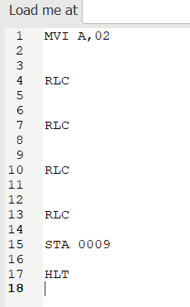  
  
**OUTPUT:**

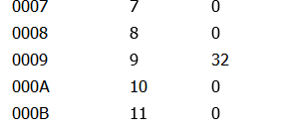  
  
  
  
**RESULT:**Thus the program was executed successfully  
using 8085 processor simulator.